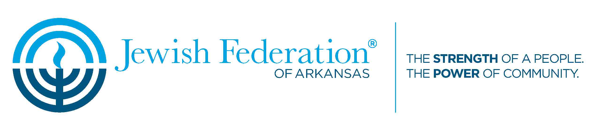

Standing Committees

- Nominating Committee –
Purpose: To select people who qualify for and meet the requirements to be a JFAR board member, understand the expectations of being a board member, and are willing to serve.

Structure: Chair + 4 members (odd number to vote)

Length of service: minimum 2 years

Time commitment: Begin the process of contacting presumptive board members early in March; present the slate to officers in May; and vote on their approval no later than July.
Occasional meetings are likely to be held by email after a committee meeting.

Goal of the committee: To present annually a slate of potential board members committed to the JFAR mission statement and enthusiastic to serve.

- Budget and Finance Committee –
Purpose: To provide financial oversight for the JFAR, to include budgeting, financial reporting, and the creation and monitoring of internal controls and accountability polices.

Structure: Chair (the treasure of JFAR) + 3 members

Length of time: to serve simultaneously as the Treasurer in service

Time commitment: Varies on the amount of policies or issues may arise. During budget preparation time will increase significantly.

Goal of the committee: To ensure that the fiduciary responsibility of JFAR are never compromised.

- Governance Committee –
Purpose: To oversee and recommend policies and procedures that ensure the efficient functioning of the board and office staff according to JFAR bylaws.

Structure: Chair + 5 members

Length of service: minimum 2 years

Time commitment: 2-3 hours monthly- essentially by email, phone or text; meet in person annually to review and update bylaws.

Goal of the committee: To be sure that all of JFARs’ policies and procedures needs are met in accordance with the current by laws.

- Campaign Committee –
Purpose: To organize and execute the annual campaign for JFAR.

Structure: Chair + 2 members

Length of service: minimum2 years

Time commitment: 3-6 hours /month.

Goal of the committee: To focus on finding targeted stewardship activities to increase pledges, to organize lists of donors past and prospective and find the appropriate persons to do the solicitation.

- Endowment Committee –
Purpose: To administer the endowments according to the EIC Constitution and review investments held by JFAR in accordance with its policies.

Structure: chair + 3 members

Length of service: minimum 2 years

Time commitment: TBD

Goal of the committee: To provide a formal quarterly review of Endowment Funds.

- Family Services –
Purpose: Works closely with JFAR’s social worker to handle confidential requests for funds by
those in need in the Jewish community.

Structure: chair + 3-4 members; JFAR social worker is ex-officio member

Length of service: as long as possible to ensure confidentiality and continuity in working on
cases

Time commitment: conducts business almost entirely over e-mail; handles on average 1-2 cases
per month

Goal of the committee: To make determinations for JFAR about providing for short-term
emergency needs (Long-term support is limited, but the social worker may be able to work
with Family Services clients to find other sustainable solutions).

Ad Hoc Committees

- Board Development-
Purpose: To enhance, encourage, educate, and motivate our board members to understand and meet the responsibilities of JFAR board members to fulfill JFAR’s mission.

Structure: Chair+ 4 members.

Length of service: 2 years.

Time commitment: 3-4 hours monthly.

Goal of the committee: To develop the JFAR board into a vibrant, focused, motivated group that works together to meet the responsibilities and mission of JFAR.

- Caregiving and Aging-
Purpose: Provides advice and guidance for JFAR’s Caregiving and Aging Programs and Services as well as for its Social Worker.

Structure: Chair/Vice-Chair, ideally with social work or health services background; members may come from throughout the Jewish community

Length of Service: minimum two years

Time Commitment: meets at least four times throughout the year; may review documents, programs, and policies over e-mail between meetings

Goal of the committee: TBD

- Jewish Food and Cultural Festival-
Purpose: The JFCF aims to bring Jews throughout the state of Arkansas together to celebrate their shared culinary and cultural tradition and to showcase those traditions to the general public, thereby increasing awareness and knowledge about Judaism and Jewish life.

Structure: Chair/Vice chair + the whole Jewish community.

Length of service: minimum 2 years

Time commitment: Varies during the year probably 1 hour per month and increase significantly 2 months before the festival.

Goal of the committee: TBD

- Our House Christmas Dinner -
Purpose: Plans JFAR’s yearly mitzvah of preparing and serving Christmas dinner at Our House.

Structure: Chair/Vice Chair

Length of service: as long as needed to plan the event in a given year

Time commitment: conducts most business via e-mail; may meet prior to event.

Goal of the committee: TBD

- Personnel-
Purpose: Oversees annual reviews of JFAR employees; provides guidance and makes recommendations to the Board Officers and the Executive Committee on Compensation.

Structure: No personnel committee members may be members of the JFAR Board.

Length of service: minimum 2 years

Time commitment: meets almost exclusively via e-mail; answers occasional questions throughout the year; workload heaviest when approving annual reviews in June

Goal of the committee: TBD

- Statewide Networking-
Purpose: Responsible for the efficacy of JFAR’s service to and communication with its constituencies outside of Little Rock.

Structure: Chair

Length of service: TBD

Time commitment: TBD

Goal of the committee: TBD

- Tikkun Olam-
Purpose: To celebrate the community.

Structure: Chair

Length of service: TBD

Time commitment: TBD

Goal of the committee: To hold an event that generates a sense of pride in belonging to our community and that raises funds to benefit JFAR’s work in the Arkansas Jewish Community.

- Yom HaAtzmaut -
Purpose: Works with the office and local rabbis to plan JFAR’s annual community Yom Ha’Atzmaut celebration.

Structure: Chair/Vice chair

Length of service: as long as needed to plan the event in a given year

Time commitment: Meets as needed to plan celebration.

Goal of the committee: TBD

- Young Adult-
Purpose: Organizes events for young adults in Central Arkansas and works with the Office to develop strategies for outreach and involvement of young adults.

Structure: Chair/Vice chair

Length of service: TBD

Time commitment: Meets multiple times throughout the year as needed to plan events.

Goal of the committee: TBD

*TBD: to be determined.

